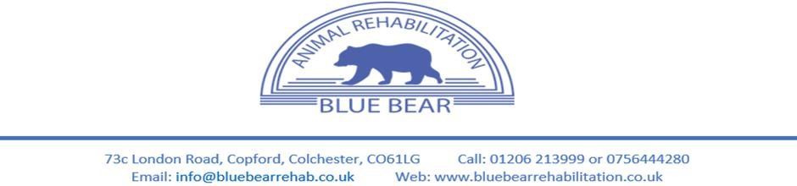

Blue Bear Animal Rehabilitation Dog Birthday Party Terms & Conditions

HEALTH & SAFETY – HUMANS - I understand that there are trip/slip hazards including other people and dogs present. I have been advised that I should wear suitable nonslip footwear. I will inform Blue Bear if I have a disability or medical condition that limits my ability to participate or puts me at greater risk of injury. I understand that I am responsible for my children’s safety and behaviour while they are on the premises and that they will always remain under my close supervision and in all areas of the centre. I understand that I am responsible for the safety of the people/visitors accompanying me whilst at Blue Bear as they may not be familiar with the procedures and hazards that I have been made aware of. Do not enter the pool room, treadmill room or physiotherapy rooms unless instructed by the member of staff present, please listen to all of their instructions. It is understood that human aggressive dogs will not be able to participate in the birthday parties.
PLEASE DO NOT wear muddy boots or shoes

HEALTH & SAFETY – DOGS
- Always have a collar and/or harness on your dog. Dogs without collars pose a serious health & safety risk to members of staff, other clients, and their dogs.
- Always keep your dog on a lead until a member of staff tells you that it is safe to release your dog/s. If you are not strong enough and have a problem controlling your dog, please ask a member of staff for help.
- Always check with us before bringing your dog into reception – your dog may be great with other dogs, but not all dogs are. Please remember we have injured dogs on the premises that could feel threatened or could be hurt by normal friendly behaviour.
- Staff are under strict orders regarding collars & leads on dogs – please listen to them. These rules are for everyone’s safety and comfort. Clients who have been warned and continue to ignore staff instructions to check before entering reception and/or control their dog(s) will not be allowed to continue using our facilities.
- Blue Bear strongly recommends your dog is vaccinated against kennel cough. The kennel cough vaccination is advised for any dog who routinely comes into close contact with other dogs. This is particularly important for older dogs and dogs with weaker immune systems. Please note, although the vaccination helps reduce the risk of infection, it doesn’t completely prevent your dog catching kennel cough. Please speak to your vet for more details.
- All dogs will need to have up-to-date vaccinations, been Titer tested, and have up-to-do flea and worm treatment.
- It is understood that dog aggressive dogs will not be allowed to participate in birthday parties.
CHANGE OF HEALTH STATUS – Any dogs that have experienced vomiting or diarrhoea less than 48 hours prior to the birthday party can no longer attend, this is to ensure that no infections are spread around our facilities as we treat many dogs. Any dogs that are also known to have an infection (e.g. Kennel cough) are also not able to attend, this to keep all other dogs attending the party and our other clients safe from the risk of infection.
TREATS – All treats provided by Blue Bear are NOT suitable for dogs that suffer with any allergies, please make staff aware if your dog does have allergies as extra precautions can be made. In this instance owners are welcome to bring their own treats with them but we ask they are of dried form to make cleaning between parties easier.
CLEANLINESS - If your dog poos – please clean up and dispose of in the poo bin provided outside. Ask if you need a poo bag or help – we do not mind, as accidents happen. Use the designated garden to toilet your dog – please do not use the car park as there can be heavy traffic and this is unpleasant & unhealthy for our neighbours, other people and wild and domestic animals.

An extra cleaning/damage fee may apply if your dog creates or causes any extreme mess or damage to the room or equipment provided. This will vary based on the incident.

APPOINTMENTS
A 50% non-refundable deposit is required at the time of booking your party.
Late Arrivals – We understand traffic and other complications can occur that can result in lateness, your party will still be able to take place however it will not be able to be extended to gain a full hour. There may be other parties after yours and therefore we will have a time to keep to.
Missed parties and late cancellations with less than 48 hours’ notice will incur the full party charge. We require a minimum of 48 hours’ notice for cancellation. You may notify us by phone or email.
GDPR – Our privacy policy can be found on our website www.bluebearanimalrehabilitation.co.uk or available on request from our team
DECLARATION - I hereby give permission for my dog to attend birthday parties at Blue Bear Animal Rehabilitation Centres. I will not bring any dog to Blue Bear which has contracted or been knowingly exposed to any infectious diseases. I agree to abide by all the Terms & Conditions which have been explained and discussed with me by a member of staff.
I give/ do not give permission for photographs to be used for monitoring progress and/or use on our social media sites and for educational or promotional purposes (please delete as appropriate.)
I give permission for Blue Bear Animal Rehabilitation Ltd to contact me as per the privacy policy

Clients Name Clients Signature
Staff Signature Date
www.bluebearanimalrehabilitation.co.uk
01206 213999 info@bluebearanimalrehabilitation.co.uk

